WIJAYAWARDHANA W.A.H.A.

2019/E/166

SEMESTER 05

23 AUGUST 2022

INTRODUCTION TO JAVA

LANGUAGE FEATURES – LAB 01

EC 5080

Question 01

package EC5080_Lab01;

import java.util.Scanner;

public class ExpressionResult {

Scanner scanner = new Scanner(System.in);

char algebraicExpression;

//Constructor.

public void ExpressionResult(){

algebraicExpression = '=';

}

/**

* getAlgebraicExpression method use to get algebraic expression from the user.

*/

public void getAlgebraicExpression(){

ExpressionResult obj01 = new ExpressionResult();

System.out.println("Enter the algebraic expression : ");

String expression = scanner.nextLine();

// String[] array = expression.split("[ ]");

toString(evaluate(expression));

}

public static int evaluate(String expression){

String[] array = expression.split("[ ]");

int result = Integer.parseInt(array[0]);

//String operation = array[1];

int operandIndex = 2;

int opratorIndex = 1;

//int[] resultArray;

int operand;

String operator = null;

while(operandIndex < array.length){

operand = Integer.parseInt(array[operandIndex]);

if(opratorIndex < array.length)

{

operator = array[opratorIndex];

}

operandIndex+=2;

//opratorIndex+=2;

if(array[opratorIndex].equals("+")){  
 result+=operand**;** }  
 else if(array[opratorIndex].equals("-")){  
 result=result-operand**;** }  
 else if(array[opratorIndex].equals("*")){  
 result=result*operand**;** }  
 else if(array[opratorIndex].equals("/")){  
 result=result/operand**;** }  
 opratorIndex+=**2;** }  
 return result**;**}

/**

*

*/

public void toString(int result){

System.out.println(String.valueOf(result));

}

public static void main(String[] args) {

Scanner scanner = new Scanner(System.in);

char methodRunning = 'A';

while (methodRunning != 'X'){

ExpressionResult obj03 = new ExpressionResult();

obj03.getAlgebraicExpression();

System.out.println("If you want to exit press X else press any one.");

methodRunning = scanner.next().charAt(0);

}

}

}

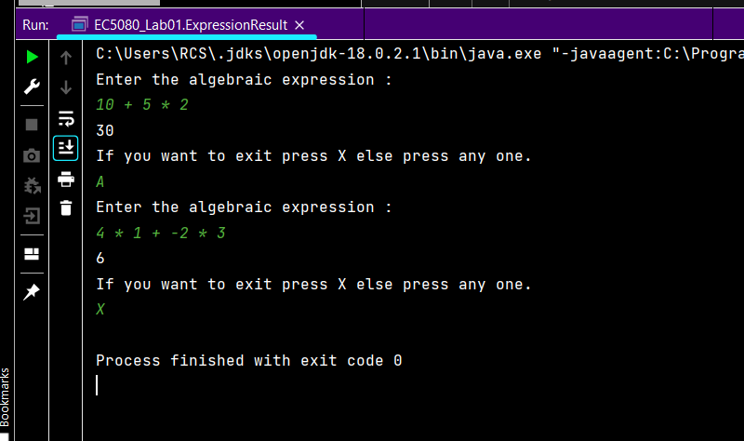

Question 02

02.

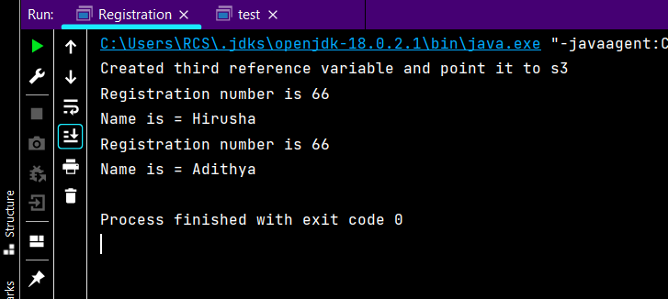

03.

a

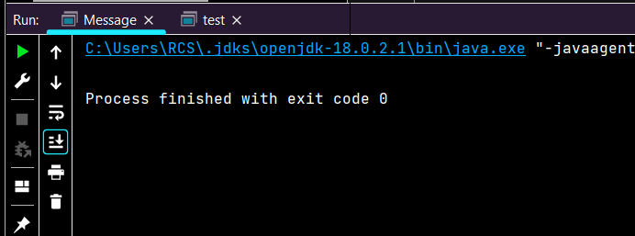

b.

public class Message {  
 String message**;** public Message(String msg) {  
 this.message = msg**;** }  
 public void display() {  
 print(this.message)**;** }  
 public void print(String message) {  
 Message msg = new Message("The message: " + message)**;** }  
 public static void main(String[] args) {  
 Message msg_1 = new Message("SC1")**;** Message msg_2 = new Message("SC2")**;** msg_1 = msg_2**;** msg_1.display()**;** new Message("SC3").display()**;** msg_1 = null**;** System.*gc*()**;** }  
 public void finalize() {  
 System.*out*.println("'" + this.message + "'" + " successfully garbage collected")**;** }  
}

Reason:

The created objects were deleted or the objects were not be crate and assign.